Bittar, Catherine (260687735) 8 December 2017

Sorto-Ventura, Kevin-Rafael (260692767) McGill University

ECSE 323: Digital System Design

Lab #5: Card Game System Integration

# 

Table of Contents

Introduction 2

g21_stack52 3

Circuit Function 3

Circuit Design 4

Registers 4

Counter 4

Mode Selection 4

Schematic 6

Simulation and Discussion 8

g21_test_bed 10

Circuit Function 10

Circuit Design 11

Single Pulse Generator 11

Stack 12

Output Assignments 12

Schematic 12

Simulation and Discussion 13

Conclusion 14

References 15

List of Figures

Figure 1 g21_stack52 functional block diagram 7

Figure 2 g21_stack52 opcode selection circuit schematic 7

Figure 3 Shift register: BUSMUX and LPM_FF pair 8

Figure 4 INIT mode simulation results 8

Figure 5 POP mode at ADDR=35 simulation results after INIT operation 9

Figure 6 PUSH mode simulation results 9

Figure 7 NOP mode simulation results after PUSH operation 9

Figure 8 RST operation simulation results 10

Figure 9 INIT mode with single clock cycle enable signal 10

Figure 10 Single pulse generator circuit schematic 12

Figure 11 g21_test_bed circuit schematic 12

Figure 12 g21_test_bed simulation results 13

Figure 13 g21_test_bed SignalTap simulation results 13

Figure 14 Compilation report flow summary for g21_test_bed circuit 14

# 

# Introduction

The purpose of this lab was to complete the design of a card game by integrating various components which were designed during the last four labs. This includes the stack, the rules modules, as well as smaller components like the 7-segment decoder. This left two components to design: the controller FSM, and the data path which includes the user interface. Both components were successfully tested directly on the Altera DE1 board.

The design was completed using the FPGA design software Quartus. This design was part of the project file *g21_lab5.QPF*.

# Deal_FSM

## **Circuit Function**

The Deal_FSM circuit is a finite state machine with 14 inputs and 12 outputs defined below. The inputs are used to determine the next state, while the outputs are used as control signals for the rest of the circuit.

|  |  |  |  |
| --- | --- | --- | --- |
| **Type** | **Name** | **Length (bit)** | **Purpose** |
| Input | Request_Deal | 1 | Button press – indicates player wants another card. |
| Input | Stop | 1 | Button press – indicates player has finished playing. |
| Input | INIT | 1 | Button press – indicates start of a new hand. |
| Input | reset | 1 | Button press – indicates player want to reset game. |
| Input | Clock | 1 | Clock signal |
| Input | Dealer_legal | 1 | True if current dealer total is less than 21. |
| Input | Player_legal | 1 | True if current player total is less than 21. |
| Input | Dealer_total | 5 | Current dealer sum. |
| Input | Player_total | 5 | Current player sum. |
| Input | Dealer_high | 1 | True when dealer sum is greater than player sum. |
| Input | Player_high | 1 | True when player sum is greater than dealer sum. |
| Input | Game_over | 1 | True if game is over (one player has won 3 out of 5 games). |
| Input | score_dealer | 2 | Number of hands won by dealer in current game. |
| Input | score_player | 2 | Number of hands won by player in current game. |
| Output | rand_seed | 1 | Starts the random address generator. |
| Output | Clear_count | 1 | Clears the counters for the number of hands won. |
| Output | Dealer_Enable | 1 | Enables card to be dealt to the dealer. |
| Output | Player_Enable | 1 | Enables card to be dealt to the player. |
| Output | player_turn | 1 | Lights an LED to indicate player turn. |
| Output | Compare_enable | 1 | Enables the comparison of the dealer and player sums. |
| Output | Count_dealer | 1 | Increment the hands won by dealer in current game. |
| Output | Count_player | 1 | Increment the hands won by player in current game. |
| Output | Count_gd | 1 | Increment games won by dealer. |
| Output | Count_gp | 1 | Increment games won by player. |

The circuit has twenty states which enable and disable different output signals that control the datapath circuit (seen in the next section). Please see *Deal_FSM.vhd* for the specific control signals at different states.

## **Circuit Design**

The circuit is described in VHDL design file *Deal_FSM.vhd*. Although the instructions [1] recommended the use of a second FSM to control the computer player, a design decision was made to integrate both in one FSM. This had the advantage of simplifying its implementation. This FSM can be broken up into four distinct operations, although each of these is composed of several states: initial card deal, player play, dealer play, comparison and winner determination.

### Initial card deal

### Player play

The counter is used to keep track of the number of registers which are in use. The lpm_counter component, from the LPM library, was selected as it offers the option of setting a predetermined value, with *sset*, as well as counting up or down, with *count_en* and *updown* [2]. The EMPTY and FULL signals are determined by comparing the number of registers in use NUM with 0 and 52.

### Dealer Play

Each selected operation requires the setting of several signals to control the registers and the counter. For example, the POP operations requires a signal to push the data up, to enable only certain registers, to set the counter to count down, and to enable the counter. To simplify the assignment of such signals, four different opcodes were created, corresponding to each mode of operation, in the form of constants, with the lpm_constant module [3]. The opcode is a 10 bit value defined below.

|  |  |  |  |  |  |
| --- | --- | --- | --- | --- | --- |
| **Signal** | **Opcode index** | **Value** | | | |
| **NOP** | **INIT** | **PUSH** | **POP** |
| data_select | 9 | 0 | 0 | 0 | 1 |
| sset | 8 | 0 | 1 | 0 | 0 |
| count_en | 7 | 0 | 0 | 1 | 1 |
| updown | 6 | 0 | 0 | 1 | 0 |
| ADDR | 5..0 | 110100 (52) | 000000 | 000000 | 000000 |

The signals functions are defined below.

|  |  |
| --- | --- |
| **Signal** | **Function** |
|
| data_select | Select data to be pushed up or down into the registers during the POP or PUSH operations. |
| sset | Set the registers and the counter to their predetermined values for the INIT operation. |
| count_en | Enables counting for the POP or PUSH operations. |
| updown | Determines if the counter counts up or down. |
| ADDR | Used in conjunction with the g21_pop_enable circuit to determine the enable signal. |

The g21_pop_enable circuit was designed in lab 2 and is used to assign the enable signal for every operation. The use of the same components for each mode of operation facilitates timing considerations which are quite relevant as discussed further. For the modes which require all the registers be enabled, INIT and PUSH, the address passed to the circuit is 000000 which returns all 52 signals high. For the no operation mode, none of the registers are enabled by passing the address 110100 (52) to the pop enable circuit which returns all 52 signals low. Finally, the address specified by the ADDR input replaces the opcode in its place for the pop operation.

As mentioned above, the use of the g21_pop_enable circuit to produce the array of enable signals for every operation facilitates timing considerations. The g21_pop_enable circuit employs ROM and it clock enabled. This causes the enable circuit to have an additional delay of 1 clock cycle. This becomes increasingly relevant when the enable signal is a single clock-cycle in length. In particular, it was found that the INIT operation was not occurring despite it being the selected mode, because the *sset* input was activated before the *enable* input was active as it did not clock dependant. The one clock-cycle delay meant that the INIT operation could not take place. To solve this issue, extra flip-flops were implemented with the opcode elements which interacted with the registers. The flip-flops, being clock-enabled as well, solved this issue. Simulations showed that the enable signal was actually 2 clock-cycles long. Consequently, two flip-flops are used to delay the rest of the opcode signals.

Depending on the selected mode, several conditions need to be checked within the circuit before executed the operation. For example, a PUSH operation can only take place if the MODE control bits are set to 10, the stack if not full, and the enable signal is on. A series of multiplexers are used to check conditions for each operation to take place. When a condition is not met, the no operation opcode is passed through.

## **Schematic**

Since the schematic of the stack is very large and complex, it is not shown in its entirety in this report. Rather, a block diagram is shown, as well as the mode selection circuit and an instance of the BUSMUX and lpm_ff pair which constitutes a shift register.

For a view of the full schematic diagram, please refer to design file *g21_stack52.bdf*.

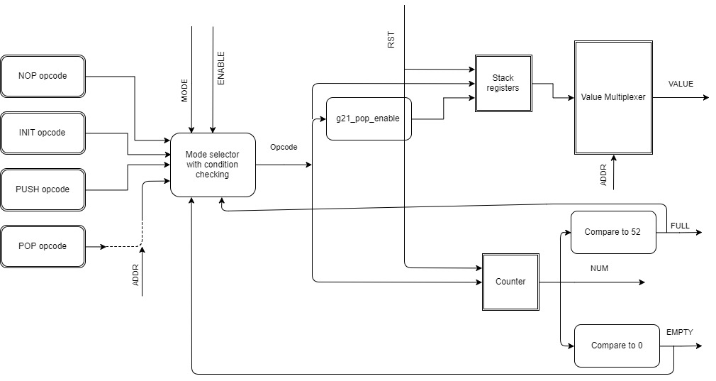

Figure 1 g21_stack52 functional block diagram

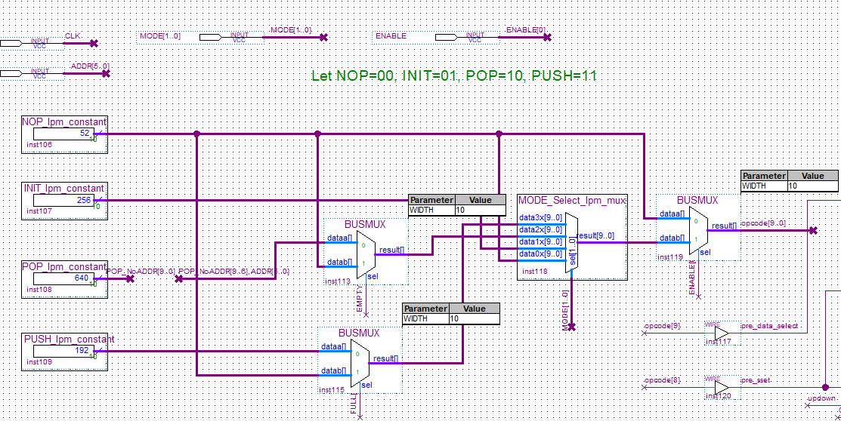

Figure 2 g21_stack52 opcode selection circuit schematic

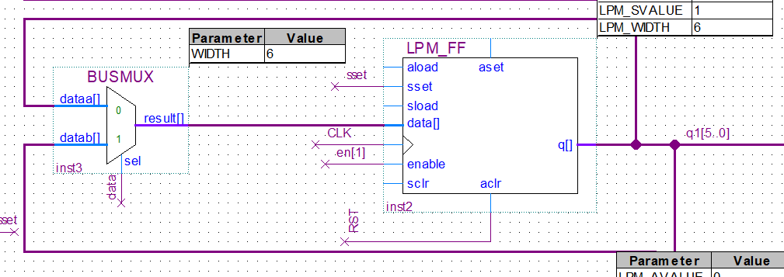

Figure 3 Shift register: BUSMUX and LPM_FF pair

## **Simulation and Discussion**

Timing simulations were done on the circuit to ensure it was functioning correctly. Tests were done using the simulation file *g21_stack52.vwf* on all four modes of operation plus the reset function. It should be noted that simulations using a constant enable signal can be misleading as it can mask timing issues as it was our case. It is important in simulations, to use waveforms which are representative of the physical signals which will be passed to the signal. As it is seen in the g21_test_bed circuit, g21_stack52 circuit is to be used with enable signals which lasted a single clock cycle. This such simulation it is important to simulate it as such as well. This can be seen in Figure 9 INIT mode with single clock cycle enable signal. It should be noted that the maximum propagation delay is 19.104 nanoseconds. This indicates the maximum operational frequency of the clock is 52 MHz. Below are snapshots of the simulation results for INIT, POP, PUSH, NOP and RST:

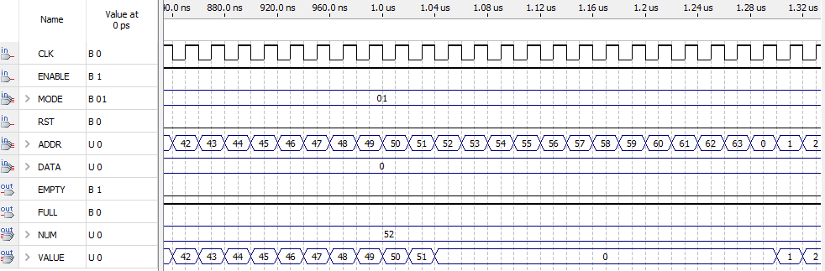

Figure 4 INIT mode simulation results

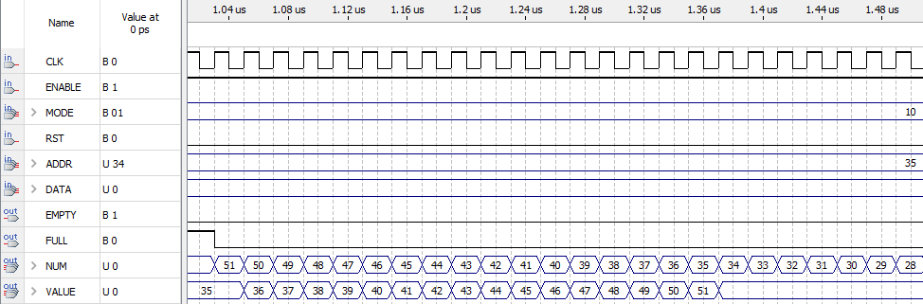

Figure 5 POP mode at ADDR=35 simulation results after INIT operation

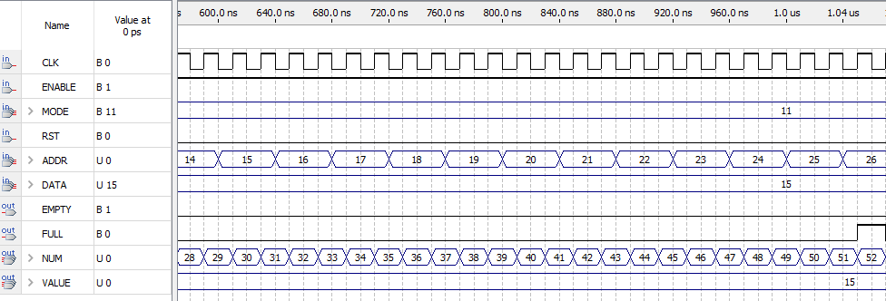

Figure 6 PUSH mode simulation results

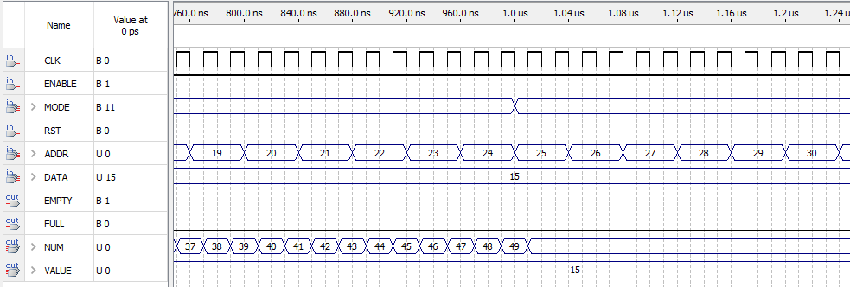

Figure 7 NOP mode simulation results after PUSH operation

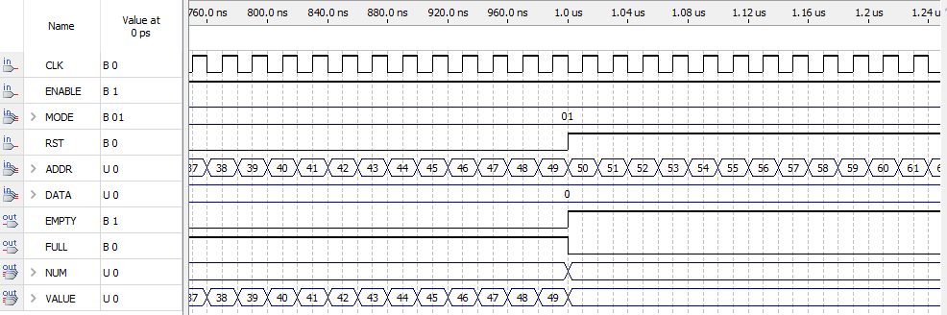

Figure 8 RST operation simulation results

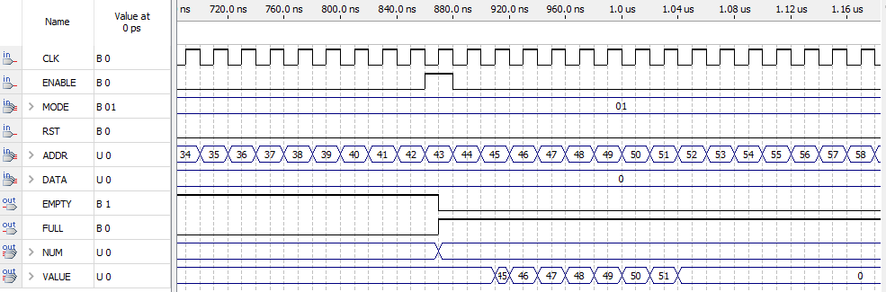

Figure 9 INIT mode with single clock cycle enable signal

# g21_test_bed

## **Circuit Function**

The test-bed circuit has 5 inputs and 6 outputs. It is used to implement the g21_stack52 circuit on the physical Altera DE1 board.

|  |  |  |  |
| --- | --- | --- | --- |
| **Type** | **Name** | **Length (bit)** | **Purpose** |
| Input | CLK | 1 | Clock Signal |
| Input | pushButton | 1 | Input mapped to a button on the board and triggers a single enable pulse |
| Input | RSTButton | 1 | Input mapped to a button on the board and triggers the reset function |
| Input | dipswitch2 | 6 | Input mapped to 6 switches on the board and defines the value of ADDR |
| Input | dipswitch1 | 2 | Input mapped to 2 switches on the board and defines the value of MODE |
| Output | LEDmod | 7 | 7-segment code for mod13 of VALUE |
| Output | LEDfloor | 7 | 7-segment code for floor of VALUE |
| Output | FULL* | 1 | Output mapped to a green LED on the board and triggers when the stack is full |
| Output | EMPTY* | 1 | Output mapped to a red LED on the board and triggers when the stack is empty |

*Note that the FULL and EMPTY outputs were not required in the lab instructions [1] but they were added to make testing on the board easier.

## **Circuit Design**

The g21_test_bed circuit is used to implement the g21_stack52 circuit on the physical board. To do so, the circuit is comprised of three parts: receive input from user, process information, show result to user. First, the circuit receives information from the user by assigning inputs to appropriate pins on the board. Additionally, a single pulse generator circuit is implemented with the enable signal as to ensure the inherent mechanical “bouncing” of the switch does not cause create noise in the enable signal. Second, the circuit performs its operation based on the input with the g21_stack52 circuit. Finally, the output is shown the user by lighting the correct LEDs available on the board.

### Single Pulse Generator

The single pulse generator functions as a gate for the enable signal. The enable signal can only be high for one clock cycle every 20 ms. This prevents several pulses going through the circuit which could cause the circuit to push a value 2-3 times instead of once. As seen in the Figure 10 Single pulse generator circuit schematic, the circuit is implemented with a counter. Once the enable signal is high, the counting begins. While the value of the counter is between 1 and 20000000, the register which holds the enable signal is cleared and the counting is enabled. Once the required time has elapsed, another enable pulse may be passed to the rest of the circuit.

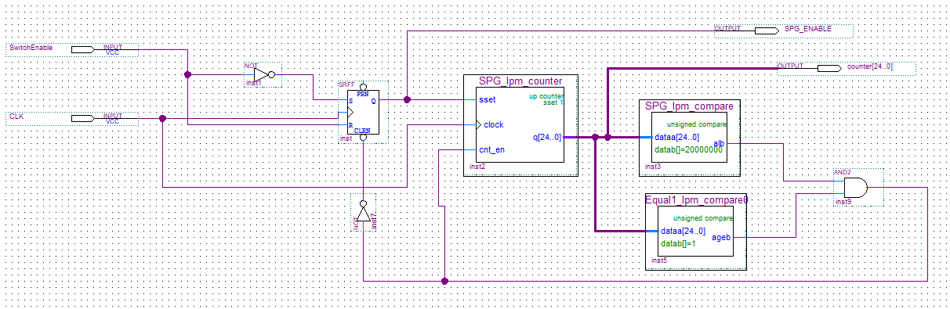

Figure 10 Single pulse generator circuit schematic

### Stack

This is an instance of the stack52 circuit that was described in the **g21_stack52** section of this report.

### Output Assignments

The outputs are shown to the user by lighting different combinations of LEDs. The FULL and EMPTY outputs are displayed by lighting a green and a red LED. The VALUE is more complicated to display as it is a 6-bit integer. Circuits which were developed in earlier labs are used.

The g21_Modulo13 circuit from Lab #1 is used to separate the VALUE into the mod13 and its floor. The user can recover the VALUE by multiplying floor by 13 and adding mod13. Each of these values is presented on a 7 segments LED display. The g21_7_segment_decoder from Lab #2 is used to properly map values to the correct pin assignments.

## **Schematic**

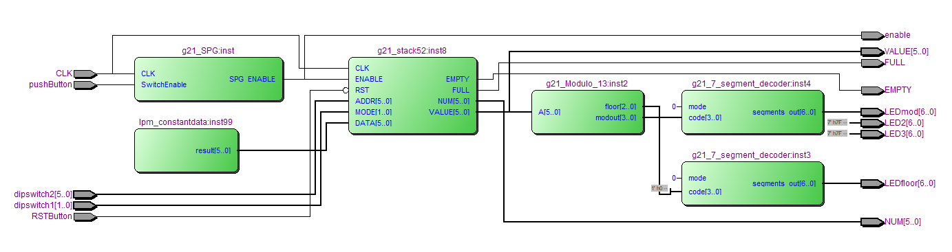

Figure 11 g21_test_bed circuit schematic

*Note that the outputs enable, VALUE and NUM are not described in the Circuit Function because they were only used for debugging purposes. Similarly, LED2 and LED3 are not actual outputs, they simply set the two unused 7-segment displays to be off.

## **Simulation and Discussion**

Timing simulations were done on the circuit to ensure it was functioning correctly. The results of the simulation can be found in Figure 12 g21_test_bed simulation results. Tests were done using the simulation file *g21_.test_bed_tim.vwf* on all four modes of operation plus the reset function. Below is a snapshot of the simulation results for INIT. Other modes are not shown as they were already tested for stack52 and the goal of this simulation is to show that the test-bed works as a whole:

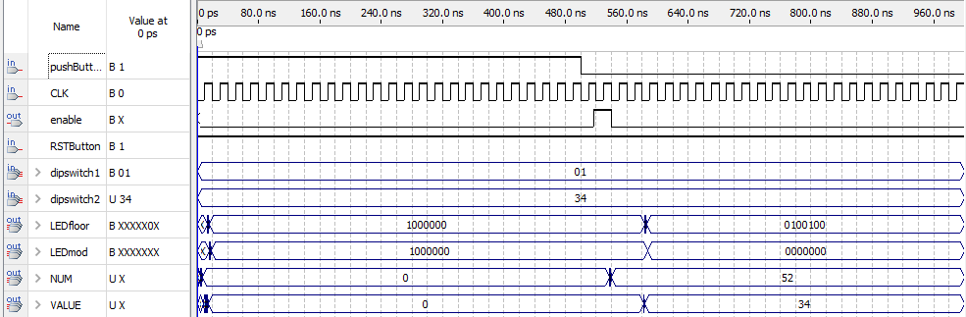

Figure 12 g21_test_bed simulation results

From the TimeQuest timing analyzer, it was determined that the longest propagation delay in the circuit was 25.839ns. This means the minimum clock frequency should allow for this delay. The associated maximum frequency is 38.7 MHz.

A SignalTap simulation wad also conducted to ensure that the circuit was functional on the DE1 board and not only when doing regular timing simulations. Here is a snapshot of the SignalTap results when ADDR (dipswitch2) = 4 and MODE (dipswitch1) = INIT:

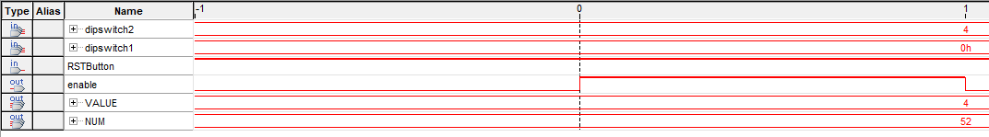

Figure 13 g21_test_bed SignalTap simulation results

Furthermore, a summary of resource utilization was extracted from the compilation flow summary. From it, information can be analyzed about the number of logic elements registers and pins that are used by the circuit on the DE1 board:

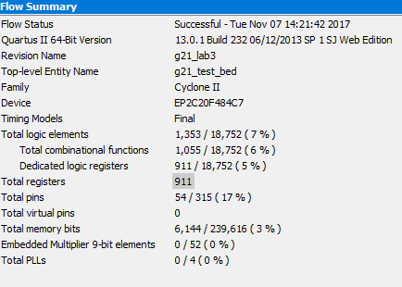

Figure 14 Compilation report flow summary for g21_test_bed circuit

# Conclusion

The g21_stack52 circuit was designed and implemented on the Cyclone II Altera DE board by using a test bed which implemented a single pulse generator. It is important to consider the application of a circuit when simulating it to ensure it functions correctly, as seen with the stack circuit timing issues. Circuits which use the stack component should have a clock frequency inferior to 52 MHz (which is fine since the DE1 board operates at 50 MHz) to account for the propagations delays.

# References

[1] Prof. J. Clark, Lab Instructions, “ECSE-323 Digital Systems Design: Lab #5 – System Integration for the Card Game”, Department of Electrical and Computer Engineering, McGill University, Nov. 2017.

[2] *LPM Quick Reference Guide*. Altera Corporation, 1996, pp. 26-28.

[3] "Opcode definition by The Linux Information Project (LINFO)", *Linfo.org*, 2017. [Online]. Available: http://www.linfo.org/opcode.html. [Accessed: 03- Nov- 2017].